H.T No
Regulations:
A20

Sreenidhi Institute of Science and Technology
(An Autonomous Institution)
Code No: 8AC42 Date: 09-Feb-2024 (FN)
B.Tech I-Year I- Semester External Examination, Jan/Feb-2024 (Supplementary)
ELECTRICAL CIRCUITS AND NETWORK ANALYSIS (ECM)

Time: 3 Hours Max.Marks:70

Note: a) No additional answer sheets will be provided.
b) All sub-parts of a question must be answered at one place only, otherwise it will not be valued.
c) Missing data can be assumed suitably.
Bloom's Cognitive Levels of Learning (BCLL)

Remember | L1 | Apply | L3 | Evaluate | L5
Understand | L2 | Analyze | L4 | Create | L6

Part - A Max.Marks:20

Answer all QUESTIONS.

 |  | BCLL | CO(s) | Marks
1 | State Kirchoff’s current Law | L2 | CO1 | [2M]
2 | Define bandwidth | L2 | CO2 | [2M]
3 | Define mutual inductance | L2 | CO3 | [2M]
4 | State Norton’s Theorem | L2 | CO4 | [2M]
5 | Write the symmetry and Reciprocity condition for ABCD parameters | L2 | CO5 | [2M]
6 | Write the time constant of series RC circuit | L3 | CO6 | [2M]
7 | Define R.M.S Value | L2 | CO2 | [2M]
8 | State Superposition Theorem | L2 | CO4 | [2M]
9 | Write Y parameters in terms of h parameters | L2 | CO5 | [2M]
10 | State Maximum power transfer theorem | L2 | CO4 | [2M]

Part – B Max.Marks:50
ANSWER ANY FIVE QUESTIONS. EACH QUESTION CARRIES 10 MARKS.

 |  |  | BCLL | CO(s) | Marks
11. | a) | In the network shown below, find the current delivered by the battery | L3 | CO1 | [5M]
 | b) | Discuss about the concept of super mesh analysis with an example. | L3 | CO1 | [5M]
12. | a) | Explain the Concept of Phase, Phase difference and j-notation in a.c. circuits. Define impedance,  admittance and reactance | L3 | CO2 | [5M]
 | b) | Derive the expression for bandwidth of a series resonant circuit. | L4 | CO2 | [5M]
13. | a) | If a coil of 0.02H is magnetically coupled to another coil of 0.01H.The coefficient of coupling  between two coils is 0.5. Calculate effective inductance if two coils are connected in ,  (i)Series aiding (ii) Series opposing | L3 | CO3 | [5M]
 | b) | Derive the expressions for equivalent inductance of two coils in parallel with  (i)Parallel aiding (ii) Parallel opposition | L2 | CO3 | [5M]
14. | a) | Find the value of RL so that maximum power is delivered to the load resistance shown in figure.  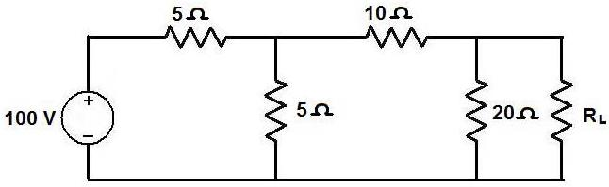 | L3 | CO4 | [5M]
 | b) | State Reciprocity theorem and explain it with an example. | L3 | CO4 | [5M]
15. | a) | 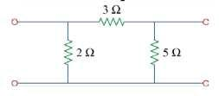  Find the ABCD- parameters for the following circuit | L3 | CO5 | [5M]
 | b) | Express Z parameters in terms of Y parameters | L2 | CO5 | [5M]
16. | a) | A dc voltage of 20V is applied in a RL circuit where R = 5ohm and L=10H. Find  a. The time constant  b. The current expression. | L3 | CO6 | [5M]
 | b) | Derive the current expression for series R-L circuit for sinusoidal Excitation. | L3 | CO6 | [5M]
17. | a) | 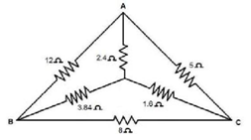Determine the equivalent resistance across AB of the circuit shown in the figure below | L2 | CO1 | [4M]
 | b) | Discuss the Steady State Analysis of series RC with Sinusoidal Excitation. | L3 | CO2 | [3M]
 | c) | Derive the expression for coefficient  of coupling. | L3 | CO3 | [3M]
18. | a) | Show that maximum power delivered to the load is maximum when R_{L}=R_{th} | L3 | CO4 | [4M]
 | b) | Express ABCD parameters in terms of Y parameters | L5 | CO5 | [3M]
 | c) | Derive the current expression for series RLC circuit for DC Excitation. | L5 | CO6 | [3M]
-- 00 -- 00 –

